Chapter 10, Problem 96.

Refer to the oscillator in Fig. 10.137.

(a) Show that

(V₂/V_{o}) = 1/[3 + j(ωL/R – R/ωL)]

(b) Determine the oscillation frequency f_{o}.

(c) Obtain the relationship between R₁ and R₂ in order for oscillation to occur.
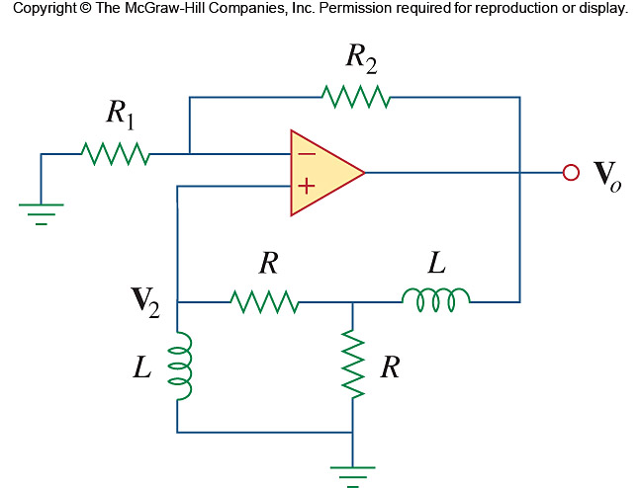

Figure 10.137
For Prob. 10.96.

